|  |
| --- |
|  |
|  |

|  |  |  |  |  |  |
| --- | --- | --- | --- | --- | --- |
| REVISION HISTORY | | | | | |
| Ver. | Description of Change | Author | Date | Approved | |
| Name | Effective Date |
| 1.0 | Initial status | [Kiryl Bucha](mailto:Kiryl_Bucha@epam.com) | 12-JAN-2012 |  |  |
| 2.0 | Updated in accordance with renewed content | [Elias Nema](mailto:Elias_Nema@epam.com) | 20-JAN-2014 |  |  |
| 3.0 | Report | Aksana Kuratnik | 07-DEC-2017 |  |  |

Contents

1. Create Packages for Reload Dimension from DW to SAL 3

2. Task Results 3

# Create package to load the Fact Table into the staging (3NF) layer

The Main Task is to create independent package[s] to load your fact table to the ST layer, according to your DWH concept that was developed on Module 6 Introduction to DWH.

# Task Results

Create required objects:

* Create all required fact table objects on ST Layer (T_...).
* Grant all required privileges to ST_CL (Cleansing Layer).
* Create packages to load fact data (one package = one fact table) on ST_CL.
* Prepare document with description of your load and screenshot of data in the Fact Table.
* Test Procedure for Repeatable execution (it should produce same consistent results each time on a same source data).

All required tables were created. The scripts are in the project folder.

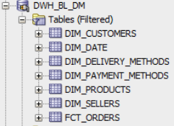

STAR Shema:

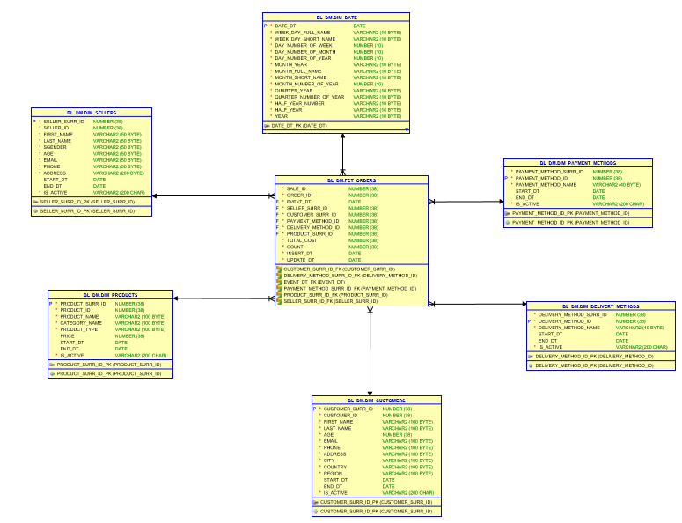

Table on 2ND BL_CL layer were created:

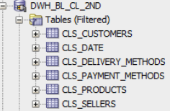

Package to insert bl_cl_2nd from bl_3nf:

CREATE OR REPLACE PACKAGE pkg_etl_insert_payment_methods

AUTHID CURRENT_USER

AS

PROCEDURE insert_cls_payment_methods;

END pkg_etl_insert_payment_methods;

/

CREATE OR REPLACE PACKAGE BODY pkg_etl_insert_payment_methods

AS

PROCEDURE insert_cls_payment_methods

IS

BEGIN

EXECUTE IMMEDIATE ('TRUNCATE TABLE cls_payment_methods');

INSERT INTO cls_payment_methods

SELECT DISTINCT

payment_method_id AS payment_method_surr_id,

payment_method_srcid AS payment_method_id,

payment_method_desc,

start_dt,

end_dt,

is_active

FROM bl_3nf.ce_payment_methods;

COMMIT;

EXCEPTION

WHEN OTHERS THEN

RAISE;

END insert_cls_payment_methods;

END pkg_etl_insert_payment_methods;

/

